Dated: 29th of March 2025.

** Contact Information **
Name: MR. Simon Paul Cordell.
Address: 109 Burncroft Avenue, Enfield, London, EN3 7JQ.
Tel:
Email: Re_wired@ymail.com

“Notice of Intent to Proceed with Legal Action for Alleged Misconduct”
INDEX

- Our Subject:
Outlines the purpose of the letter, which is to initiate pre-action conduct proceedings and present a compensation claim due to submitted allegations.

- Introduction:
Provides an overview of my situation, highlighting the key grievances, including misconduct, racial profiling, and harassment by government officials.

- Time Limits:
Specifies the deadlines for responses and actions required under “Pre-Action Protocols,” ensuring compliance within established timeframes to prevent undue delays.

- The Accused Company Details in a Year Order of Accused as Liable:
Lists the organisations held liable for misconduct, sorted chronologically by the years of the incidents.

- We Request for Compliance with the Practice of Directions for Pre-Action Conduct:
Explains the requested steps for compliance under “Pre-Action Protocols,” such as providing relevant documents and exploring alternative dispute resolution.

- Nature And Summary of The Claim:
Summarises the allegations, including profiling, conspiracy, fraud, and deliberate endangerment, alongside my compensation request.

- Our Summary of Facts:
Highlights significant incidents and injustices, such as alleged forgery, coordinated efforts to discredit me, and failures by officials to acknowledge critical evidence.

- This Is About Our Provided List of Documented Evidence:
Discusses the range of evidence submitted, including case files, recordings, medical reports, and other documents organised for the claim.

- About The Evidence We Have Presented:
Details key evidence used to support the allegations, including specific documents like PNC records and forged reports Exhibits in our “N1 Claim Form.”

- Our Requests:
Lists Our formal requests, such as initiating an investigation, immediate rehousing, compensation, and deletion of government records.

- In Accordance with The Practice Direction on Pre-Action Conduct, We Request That You Provide Us with Copies of The Following Documents:
Specifies additional documentation required from the accused parties, along with my openness to alternative dispute resolution.

- P.S:
Identifies potential legal breaches relevant to my case and emphasises the need for urgent compliance and resolution.

- Our Conclusion:
Calls for a thorough investigation and resolution within a set timeframe, stating that legal proceedings will follow if no response is received.

- Our Subject: Request For “Pre-Action Conduct” Prior To Court Proceedings and A Subsequent Compensation Claim, Due to our submitted Claims.

- Introduction

Dear Sir/Madam,
I am writing as the Claimant, Mr. Simon Paul Cordell, a mixed-race male who has been subjected to a series of deeply concerning incidents. These incidents include alleged racial and discriminatory profiling, as well as subsequent harassment by the police and other local authorities listed in this document. Regrettably, my previous interactions with these local authorities have not led to a satisfactory resolution, despite significant efforts to address these matters through amicable means.

The circumstances outlined in this document have arisen as a result of specific Government staff members failing to adhere to lawful standards and regulatory procedures. These failures have allowed certain individuals, or their colleagues, to avoid accountability for alleged misconduct while acting in official capacities representing Government entities.

In this matter, I am acting as a “Litigant in Person” unless I determine it necessary to engage legal representation at a later stage. Given the additional effort and challenges involved in preparing and presenting this case myself, I am requesting compensation for the time and resources expended in my role as a litigant. This request is in line with “Part 46 Of the Civil Procedure Rules (CPR), Specifically Practice Direction 46.5,” which provides guidance for awarding costs to litigants in person.

Despite repeated attempts to resolve these issues with the implicated Government officials and management, they have failed to reach a fair and satisfactory resolution. As such, it has become evident that I may need to initiate legal proceedings through the submission of a “N1 Claim Form” if these matters are not addressed appropriately and in accordance with this “Pre-Action Conduct letter.”

Time Limits
- About The Time Limits And Extensions Permitted To This Case
- The “Limitation Act 1980,” particularly “Section 32,” provides “Critical Exceptions” to the standard time limits for initiating claims, allowing extensions when fraud, concealment, or extraordinary circumstances have obstructed the claimant's ability to act. In this case, the cumulative evidence clearly demonstrates that systemic collusion, deliberate misconduct, and ongoing harm existed, which all justify the time extension in the time limitation period.
- The key points in relation to the time limitation period and this claim include:

- Fraud and Deliberate Concealment:
- Under “Section 32 of the Limitation Act 1980,” the limitation period is suspended until the claimant discovers or could reasonably have discovered the fraud or concealment. This principle applies to the fraudulent contradictions found within the “PNC Printout and Acro Record,” which have resulted in a fabricated criminal record associated with Mr. Simon Cordell’s name.

- Contradictions and Impossibilities
- The entries in the “PNC Printout” and “Acro Record” contain irreconcilable discrepancies. These include:
- “Charge Times” at the police station and “Plea Dates” at the court, which are impossibly scheduled during hours when the courts would have been closed (E.G., Nighttime).
- There is “Fabricated Intel Within The Records” that tarnish the integrity of the data, making the timelines and accusations impossible to reconcile.

- For Instance:
- Convictions show unexplained contradictions between sentencing dates and alleged offence dates, which defy procedural protocol.

- Failure to Rectify and Passing of Accountability
- Despite being alerted to these irregularities, the police and courts have repeatedly failed to follow protocol and rectify the errors. Instead:
- Responsibility has been passed back and forth between the police, courts, and Acro department without resolution.
- Additional fabricated offences have been created during these exchanges, further exacerbating the issue and preventing the claimant from addressing the matter in a timely and fair manner.
- It is contended that the “Mental Health Services” have been improperly utilised to undermine justice and to systematically defame Mr. Simon Cordell's character. This exploitation of mental health support mechanisms serves to diminish the integrity of his testimony in judicial settings and other official proceedings. Furthermore, it has become evident that requests for legitimate assistance have been unreasonably denied, further exacerbating the injustice faced by Mr. Cordell.

- Systemic Collusion
- The delays and fabrications were not isolated incidents but part of a “Coordinated Effort,” as evidenced by:
- References to "Joint Circular" meetings between the police, council, doctors, and other entities, during which actions were coordinated to discredit and obstruct Mr. Cordell’s claims.
- This collusion not only compounded the fabrication of offences but actively delayed any opportunity for the claimant to respond or rectify the fraudulent record.

- Critical Observations of Fabricated Records
- Upon Review of the 2012 PNC Printout:
- The "PNC Printouts" indicate that the first date for each conviction represents the court sentencing date. However, ambiguity has persisted regarding the meaning of the second date, which could either signify a "Plea Date" or an "Offence Date." Following consultations with Police, Court Officials, and Artificial Intelligence systems, it has been unequivocally confirmed that the "PNC Printouts" are strictly “Court Records.” As such, they are only mandated to record the following: - “Court Sentencing Dates - Court Plea Dates - Court Conviction Dates.”
- Notably, "PNC Printouts" are not required to document “Offence Dates.” This contradiction directly undermines the reliability of the "Acro Report," as its “Offence Dates” mirror those of the "PNC Printouts" and its "Plea Dates." Further exacerbating concerns of fraudulent activity, the "Acro Report" lists "Police Station Charged Times" that coincide with times when courthouses are officially closed. These inconsistencies go beyond mere assumptions, presenting compelling evidence of potential fabrication.
- Specific Examples of Fraudulent Data: Convictions “Fourteen” and “Sixteen” distinctly illustrate these issues, highlighting the discrepancies and further supporting my claims of fraudulent irregularities.

One of Three
- Demonstrating Three Pieces of Evidence Supporting Fraud Claims in Our N1 Form
- One of Three: “Critical Issues Highlighted in Offence Number 1 from the PNC Printouts:
- Notably, offence number 1 within the "PNC Printouts," as shown in the screenshot below, demonstrates significant flaws in the official format. Specifically, the text is entirely “Uppercase” and lacks “Abbreviations,” what is a critical formatting issue that renders the criminal record unreliable and fails to fulfil its intended purpose.

- Problematic Presentation:
- The absence of punctuation (such as full stops) and the lack of lowercase letters create a deceptive appearance, making it challenging to distinguish between key pieces of information. This confusion is exacerbated without specialized knowledge of the system and its mandatory documentation standards.

- Impact on Interpretation:
- When reading the text, one is led to believe that the information refers to an "Offence Date." However, upon closer examination, it is apparent that this is the “Court Plea Date” and not the offence date—further supporting claims of error or deliberate misinformation.

- Screenshot PNC Record: Exhibit 1
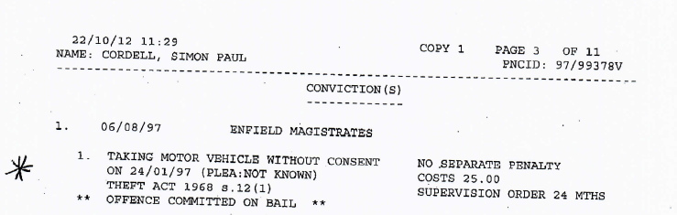
- Original PNC Printout File Link:
- https://horrific-corruption-files.webhop.me/PNC66/1.%20PNC-Errors-and-Its-Other-Claims/1.%20New-PNC-Claim-Folder/2.%20The-PNC-Exhibited-Evidence-4-Court/2.%20Exhibited/01.%20Plea-Dates-or-Offence-Dates/01-PNC%202012-and-2014-Printouts/1-Orig12-PNC-Pri.pdf

- All
- Plea-Dates-or-Offence-Dates

- The First Date Of The 06/08/97: this date is the date I was supposed to have attended the courthouse!
- The offence: “Taking Motor Vehicle without consent” is a [36-Bit Word Count] and this includes its “Whitespace!” but you cannot define what is what between the offence date or the plea date of the 24/01/97 and this is because there is no “Uppercase” and “Abbreviations,” in the text nor is there any “Whitespace” left at the end of the sentence due to its length, leaving any person unable to be sure of the offence date or plea date.
- In the next exhibited screenshot demonstrated by us, the word count is much shorter and due to this once noticed you can see the white space at the end of the texted sentence!
- The offence: “Theft of Vehicle” is a [16-Bit Word Count] and this includes its “Whitespace!”
- And due to this time, there being “Whitespace” left at the end of the sentence it becomes proved that the date of the 24/01/97 is not the “Offence Date” And Really The Plea Date!”

** ------Next------- **

- Screenshot PNC Record: Exhibit 2
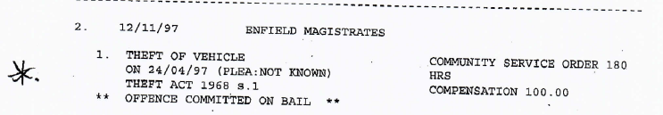
- Now if we copy the Plea date from the second entry from the PNC Printout of the 24/04/97 and then open the Acro report and enter the plea date obtained from the “PNC Printout” into the “Acro Report’s” search option, we will be taken to the second section out of the two Titled as: “Disposable,” for this case, as web-linked here:
- Original ACRO File Link:
- https://horrific-corruption-files.webhop.me/PNC66/1.%20PNC-Errors-and-Its-Other-Claims/1.%20New-PNC-Claim-Folder/2.%20The-PNC-Exhibited-Evidence-4-Court/2.%20Exhibited/01.%20Plea-Dates-or-Offence-Dates/02-ACRO-Printouts/

- There are two sections to keep in mind within the “Acro Report.” Both sections contain the information about arrest: “1. PNC Printout: (Theft of Vehicle,)” the first of the two sections is titled as “Arrest” and it exhibits the police station details, such as the Arresting Officer also, the Summons Number and the Final Decision, ‘If Charged,’ at the police station. While the second section is titled as “Disposable” and this section in the Acro Report exhibits the Courts stages detailing the attendances, any pleas and the Court Final Outcomes!

- Title: Disposable: “The dates taken from the Court Convictions out of the PNC Printout will only ever show the Disposables in the Acro Reports, we must then take the summons number from that case and research with that summons for the Arrest!”

** ------Next------- **

- The First PNC Printout Offence: “The 24/01/97” Contacts with the 76th “Acro Report” Court’s “Disposable”

- Screenshot Acro Report: Exhibit 3
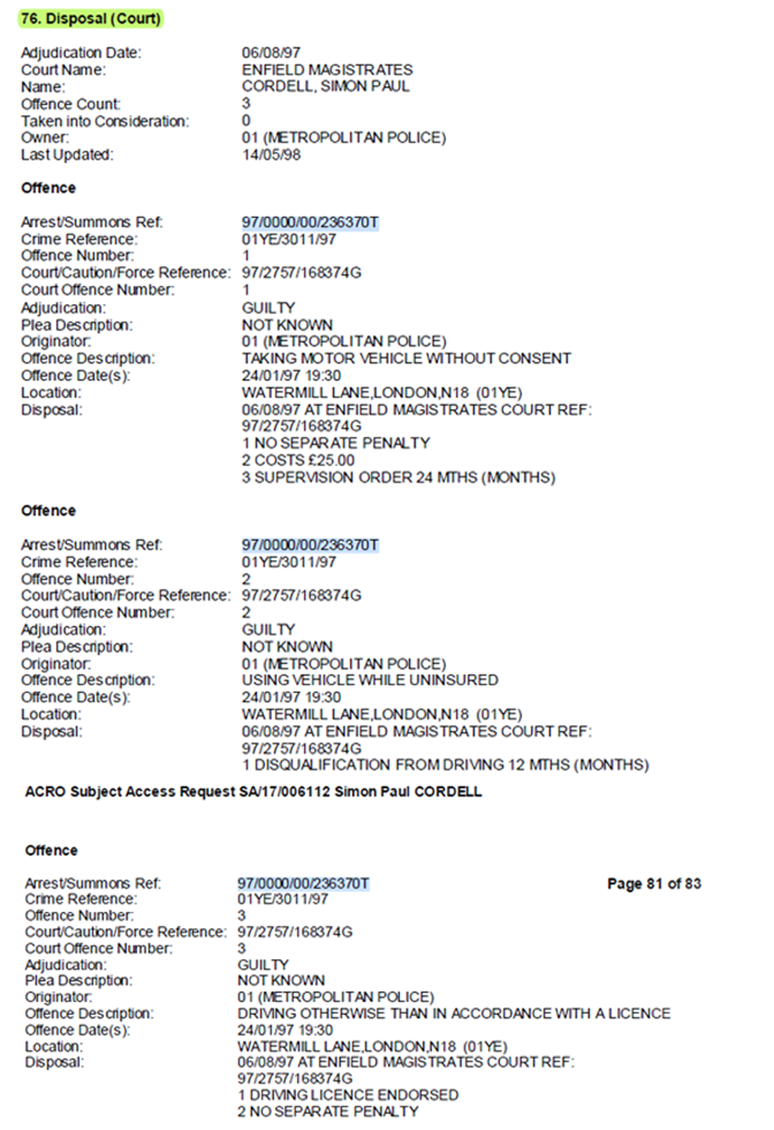
- There are three Police Charges listed here under the date of the 24/01/97 and the offences are not of the importance at the moment but what is of the importance is the summons number and the “Offence Date(s)” “Times”: I.E., 19:30, as the courts would be closed.
- Arrest/Summons Ref: 97/0000/00/236370T.

** ------Next------- **

- The Second PNC Printout Offence: “The 24/04/97” Contacts with the 74th “Acro Report” Court’s “Disposable””

- Screenshot Acro Report: Exhibit 4
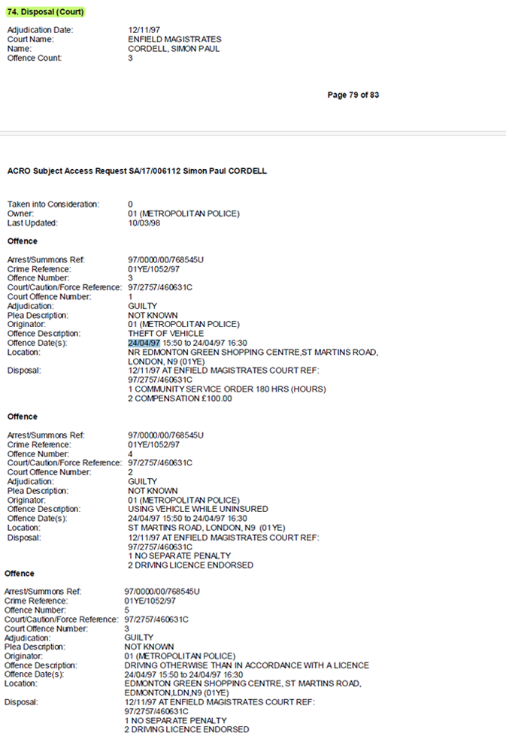
- There are three police charges listed here under the date of the 24/04/97 and the offences are not of the importance at the moment but what is, becomes the: --
- Offence Date(s): 24/04/97 15:50 to 24/04/97 16:30 “This Means I Was Arrested At This Time.”
- The time of offence is 15:50 and 16:30 and the courthouse would have been closed after this time.
- Also, copying the arrest summons ref number and placing it back into the search option of the document so we can check the arrest details for it.
- Arrest/Summons Ref: 97/0000/00/768545U.

** ------Next------- **

- The First PNC Printout Offence: “The 24/01/97” “Arrest”
- Arrest/Summons Ref: 97/0000/00/236370T.
- Screenshot Acro Report: Exhibit 5
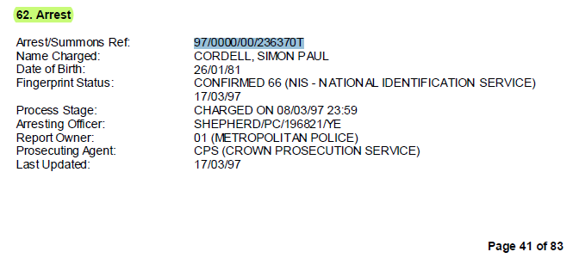
- Titled as: 62 Arrest.
- The charge time at the police station is provided here and this is it: “Process Stage: CHARGED ON 08/03/97 23:59.” The date and time come into motion.

- Acro Report Details:
  - Offence Date(s) and Time Acro Disposable: = “24/01/97” “19:30” Friday.

  - Charged Date and Time Acro Arrest: = 08/03/97 23:59. “Saturday”
- The courts would have been closed by 5pm on the 24/01/97 when I was at the police station at the time of “19:30” and therefore I would not have been transported to Tottenham Lord Ship Lane Lower Court in time.
- The date and time of charge is the 08/03/97 at 23:59, it is after the date of offence date and that of the plea date, which is stated to be the 24/01/97.

** ------Next------- **

- The Second PNC Printout Offence: “The 24/04/97” “Arrest”
- Arrest/Summons Ref: 97/0000/00/768545U.
- Screenshot Acro Report: Exhibit 6
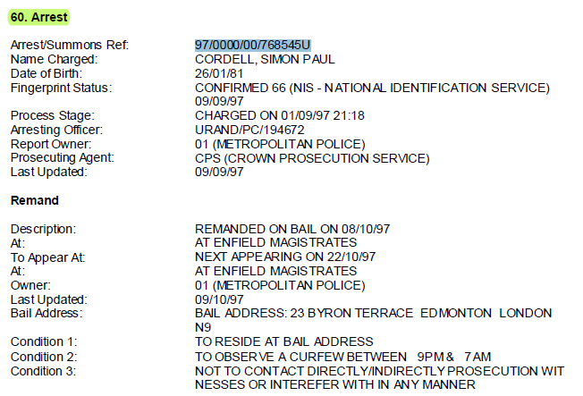
- Titled as: 60 Arrest.
- The charge time at the police station is provided here and this is it: “Process Stage: CHARGED ON 01/09/97 21:18.” The date and time come into motion.

- Acro Report Details:
  - Offence Date(s) and Time Acro Disposable: = “24/04/97” 15:50 to 24/04/97 “16:30” Thursday.
  - Charged Date and Time Acro Arrest: = 01/09/97 21:18. “Monday”
- The courts would have been closed by 5pm on the 24/04/97 when I was at the police station at the time of “16:30” and therefore I would not have been transported to Tottenham Lord Ship Lane Lower Court and seen within 30 minutes.
- The date and time of charge is the 01/09/97 at 21:18, it is after the date of offence date and that of the plea date, which is stated to be the 24/04/97.

** ------Next------- **

- Additional Two Exhibited Example’s:
Both of these examples display later timestamps than the previously exhibited case titled “The Second PNC Printout Offense: 24/04/97,” which is time-stamped at “16:30 hours.” These discrepancy raises significant concerns regarding the accuracy of the records, as they indicate fraudulent activities. Specifically, these later timestamps:
- Case 22 PNC Report and Arrest 41, Acro Report, with a Charge Time of : 22:45. Dated: 02/11/02.
- Case 23 PNC Report and Arrest 42, Acro Report, with a Charge Time of : 19:08. Dated: 17/06/02.
- suggest that the courthouse had already closed at the time recorded, further substantiating the argument that the cases in question contain fraudulent erroneous information.

- Screenshot Acro Report: Exhibit 7
★
22. | 24/04/03 Enfield Magistrates
1. | 1. Possession of A Class B Drug - Cannabis Resin .  On 02/11/02 (Plea: Not Known)  Misuse Of Drugs Act 1971 S.5(2) | No Separate Penalty Forfeiture/Confiscation of Cannabis
★
23. | 24/04/03 Enfield Magistrates
1. | Taking Motor Vehicle Without. Consent On 17/06/02 (Plea: Not Known)  Theft Act 1968 8.12(1) | Imprisonment 6 MTh’s.
2. | Using Vehicle While Uninsured On 17/06/02 {Plea: Not Known) Road Traffic Act 1988. S.143 (2) | No Separate Penalty Disqualification from Driving 12 MTh’s Varied on Appeal 25/07/03 Disqualified Reduced From 12 Months To 3 Months Driving Licence Endorsed
3. | Driving Without Reasonable Consideration  On 17/06/02 (Plea: Not Known) Road Traffic Act 1988 S.3 . | No Separate Penalty Disqualification from Driving 12 MTh’s Varied on Appeal 25/07/03
Continued On Next Pape
4. | 24/04/03 Enfield Magistrates (Coni . Driving Without Reasonable+ (Cont.)

- ScreenshotPlea-Date-or-Offence-Date-Acro2017: Exhibit 8

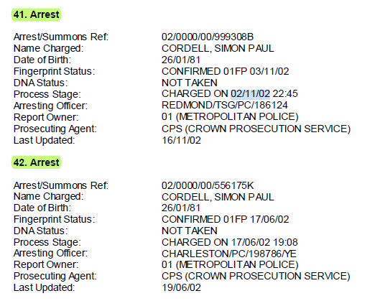

- Case 22 PNC Report and Arrest 41, Acro Report, with a Charge Time of : 22:45. Dated: 02/11/02:
“Case 22 in the 2012 PNC Printout,” is for “Possession of A Class B Drug - Cannabis Resin,” and this text wrongly spreads across two lines and has “Whitespace At The End Of It!” and this proves that the date of the 02/11/02 is a plea date.
- The Plea Date: 02/11/02,
- Plea Outcome: (Plea: Not Known)
- This Data contains a concise description, aligning with our exhibited facts and demonstrates data that does not corresponds with the courts opening times.

- Case 23 PNC Report and Arrest 42, Acro Report, with a Charge Time of : 19:08. Dated: 17/06/02:
“Case 23 in the 2012 PNC Printout,” is for “Taking Motor Vehicle Without. Consent On 17/06/02 (Plea: Not Known)”
- The Plea Date: 17/06/02,
- Plea Outcome: (Plea: Not Known)
- This Data contains a concise description, aligning with our exhibited facts and demonstrates data that does not corresponds with the courts opening times.
- Punctuation: when overviewing the data provided it is noticeable that the full stop in the grammar after “Taking Motor Vehicle Without,” is located in the wrong location and makes the details read as if this is the “Offence Date” and not “The Plea Date” as it must do.

- As a Fact, this happens through the complete official record and cases titled under arrest that have a later time of police charge than the courthouse would be opened or a weekend day when they would not be opened are not possible as well!

- These findings establish that the Acro records are fabricated, and this is further substantiated by their reliance on manipulated data.

- I have included an Exhibited video that demonstrates the bases of this claim!
- Screenshot- Video: Exhibit 9
- horrific-corruption-files.webhop.me/PNC66/1. PNC-Errors-and-Its-Other-Claims/1. New-PNC-Claim-Folder/01. Plea Dates or Offence Dates.mp4

Two of Three
- More Findings That Guarantee Fraud Within the Acro Record that Has Occurred is:

- Definition of Reprimands/Warnings/Cautions:
- This refers to “Police Cautions,” which are a method for resolving minor criminal allegations without proceeding to court. The timeline is pivotal in verifying the validity of the PNC entries and aligning them with actual procedural norms.

- Extract from the PNC Printout:
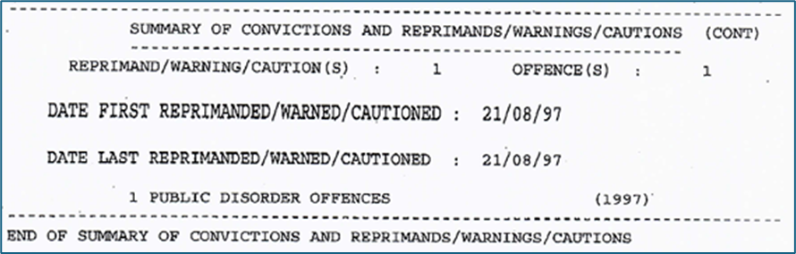

- Despite the clear reprimand timeline of 21/08/97, entries prior to this date reveal contradictions, raising concerns about fraudulent entries in the PNC Printout that is a model of the Acro Record.

- Detailed Timeline Analysis of Pre-Reprimand Offences:
- 17/01/97 (Court Plea Date 1): “Court Adjudication Date: This is the date to Compare against.”
- Details:
- Robbery under Theft Act 1968 S.8.
- Associated with an unexplained reference to "Pizza."

    - Court Sentencing:
- 21/05/98 (5th sentencing date). “This is addressed below the next screenshot and its text version.”

    - Contradictions:
- 21/05/98:
- is missing from the court registry (Case Ref: 97/0000/00/193878F,) this is as proved by my mother emails and the government officials who were also involved as detailed below in the next section of this “Pre-Action Conduct Letter!”
- If accurate, I would have been in prison as of 20/05/98 before this court date and was not made aware! “This is addressed below the next screenshot and its text version.”
- This alleged offence “Precedes” the first reprimand/warning date 21/08/97, rendering it inconsistent with procedural norms.
- The Arrests section in the Acro 2017 Report States: that I was Charged On: 28/02/97 at 16:51, Arrest 63.Arco, so if I was charged on this date, it would still mean that this was before the first reprimand/warning dated 21/08/97, and I could not have put a plea in at court on the 17/01/97 at I had not been charged.

    - Additional Notes:
- This is Arrest 63. Disposable 67. In the Acro Report 2017.
- This is also Conviction 9 in the 2012 PNC Printout.

- Screenshot-Before Pre-Reprimand and/or Police Caution Offences: Exhibit 10, Conviction 9 “Snippet from PNC File.”
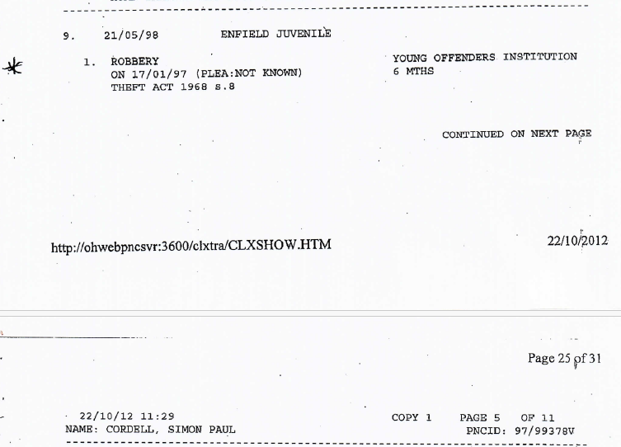
- Screenshot-Before Pre-Reprimand and/or Police Caution Offences: Exhibit 10, Conviction 9 “Text Version of Snippet above from PNC File.”
★
9. | 21/05/98 Enfield Juvenile
1. | 1. Robbery '  On 17/01/97 (Plea: Not Known) Theft Act 1968 S.8 | Young Offenders Institution 6 MTh’s

    - Additionally Addressing: “2+ If accurate, I would have been in prison as of 20/05/98 before this court date and was not made aware!

- Screenshot-Before Pre-Reprimand and/or Police Caution Offences: Exhibit 10, Conviction 9 “Text Version of Snippet above from PNC File.”

PNC Printout
This is a separate case to the exhibited case above, but it demonstrates that I could not have been in court on this day as I was in HMP Custody.
This is Conviction 5 from the 2012 PNC Printout.
★
This is the 2014 PNC Printout!

5. | 20/05/98 Enfield Magistrates
1. | 1. Burglary and Theft - Non-Dwelling On 03/01/98 (Plea: Not Known)  Theft Act 1968 S.9(1)(B) | Young Offenders Institution 6 MTh’s At Feltham  DO THREE Months = The date 6 months after 20th May 1998 would be 20th November 1998.  Sentence: 20/05/98 till 20/11/98.  Do 3 month inside from the 20/05/98 till 20/08/98 then the rest on Licence.

PNC Printout Conviction Intel: 9
- 17/01/97 (Court Plea Date 1): this is supposed to be the offence date and plea date and is the “Earliest Date” in the PNC Printout and Acro Report, meaning that this is supposed to be the first time I was ever arrested, and this is not true and never happened.
- Search the PNC Printout and the Acro Report Records for: 01/97” and by doing this and checking the search options will prove this to be recorded as the first ever offence committed, as there are no dates earlier.
- PNC Printout 2012 States: the first reprimand/warning date is 21/08/97 and this is after “17/01/97 (Court Plea Date 1),” meaning that the records are frauded.

PNC Printout Conviction Intel: 5
    - Now we are going to prove I would have been in prison as of 20/05/98 before this court date and was not made aware as I was not brought to court as the plea outlines!
- If accurate, the “20/05/98 PNC Printout Conviction 5” proves that I would have been in prison as of 20/05/98, what is 1 day before the 21/05/98 and this means that I was not made aware or brought to court, due to the plea date and not being able to attend the Court House unless arranged and brought to it by prison staff. I would have been on a prison induction wing and not registered completely into the system.
- Details PNC Printout 2012:
Conviction PNC Printout is: 5.
Plea Date: 03/01/98
Sentenced at Enfield Magistrates: 20/05/98.
- Details Acro Record 2017:
Arrest/Summons: 98/0000/00/5553D.
Disposable Court: 71.
Offence: 56. Arrest
Offence Date: 03/01/98
Offence Time: 20:00
Process Stage: Charged On 04/01/98.
Process Stage: Charged Time 18:05.
- As it is recorded, this demonstrates that the records state that I went to prison on the 20/05/98 for 6 months to the Young Offenders Institution Feltham. Then this would mean that I would have been released on Licence by the: 20/08/98, Three months later with good behaviour but none of this happened.
- It is also important to keep in mind that there are 1997 and 1998 dates both involved.

** ------Next------- **

- 24/01/97 (Court Plea Date 2): “Court Adjudication Date: This is the date to Compare against.”
- Details:
- Taking a motor vehicle without consent.
- Driving-related offence.
- Court Sentencing:
- 06/08/97 (1st Court Sentencing Date).
- Contradictions:
- 06/08/97:
- missing from the court registry (Case Ref: 97/0000/00/236370T). this is as proved by my mother emails and the government officials who were also involved as detailed below in the next section of this “Pre-Action Conduct Letter!”
- This “Offence” “Precedes” the first reprimand/warning date 21/08/97, undermining its legitimacy.
- This “Court Sentencing” date “Precedes” the first reprimand/warning date 21/08/97, undermining its legitimacy.
- This is Arrest 62. Disposable 76. In the Acro Report 2017.
- This is also Conviction 1 in the 2012 PNC Printout.
    - Additional Notes:

- Screenshot-Before Pre-Reprimand and/or Police Caution Offences: Exhibit 11, Conviction 1 “Snippet from PNC File.”
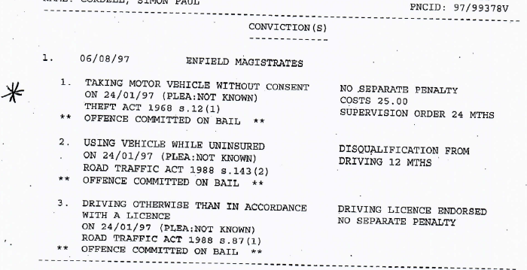
- Screenshot-Before Pre-Reprimand and/or Police Caution Offences: Exhibit 11, Conviction 1 “Text Version of Snippet above from PNC File.”
★
1. | 06/08/97 Enfield Magistrates
1. | Taking Motor Vehicle Without Consent On 24/01/97 (Plea: Not Known)  Theft Act 1968 3.12(1) | No .Separate Penalty Costs 25.00  Supervision Order 24 MTh’s
* * | Offence Committed on Bail **
2 . | Using Vehicle While Uninsured On 24/01/97 (Plea: Not Known) Road Traffic Act 1988 S.143(2) | Disqualification From Driving 12 MTh’s .
* * | Offence Committed on Bail **
3 . | Driving Otherwise Than in Accordance  With A Licence  On 24/01/97 (Plea: Not Known)  Road Traffic Act 1988 S.87(L) | Driving Licence Endorsed No Separate Penalty
* * | Offence Committed on Bail **

** ------Next------- **

- 24/04/97 (Court Plea Date 4): “Court Adjudication Date: This is the date to Compare against.”
- Details:
- Theft of a vehicle.
- Court Sentencing:
- 12/11/97 (2nd Sentencing Date). This date is not before the “The First Reprimand/Warning Date!”
- Contradictions:
- 12/11/97 missing from the court registry (Case Ref: 97/0000/00/768545U). this is as proved by my mother emails and the government officials who were also involved as detailed below in the next section of this “Pre-Action Conduct Letter!”
- The (Case Ref: 97/0000/00/768545U,) starts to cause an issue but it has to be addressed under the last table of this kind due to it needing its own table to be exhibited!
- This offence “Precedes” the first reprimand/warning date 21/08/97.
    - Additional Notes:
- This is Arrest 60. Disposable 74. In the Acro Report 2017.
- This is also Conviction 2 in the 2012 PNC Printout.

- Screenshot-Before Pre-Reprimand and/or Police Caution Offences: Exhibit 13, Conviction 2 “Snippet from PNC File.”
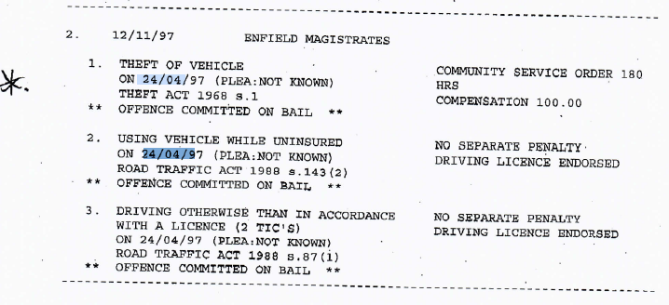
- Screenshot-Before Pre-Reprimand and/or Police Caution Offences: Exhibit 13, Conviction 2 “Text Version of Snippet above from PNC File.”
★
2. | 12/11/97 Enfield Magistrates
1 . | Theft Of Vehicle ' . On 24/04/97 (Plea: Not Known)  Theft Act 1968 S.L | Community Service Order 180 Hrs  Compensation 100.00
* * | Offence Committed on Bail **
2 . | Using Vehicle While Uninsured On 24/04/97 (Plea: Not Known) Road Traffic Act 1988 S.143(2) | No Separate Penalty Driving Licence Endorsed
* * | Offence Committed on Bail **
3 . | Driving Otherwise Than in Accordance with A Licence (2 Tic's)  On 24/04/97 (Ple Not Known)  Road Traffic Act 1988 S.87(I) | No Separate Penalty Driving Licence Endorsed
* * | Offence Committed on Bail **

** ------Next------- **

- 22/05/97 (Court Plea Date 5): “Court Adjudication Date: This is the date to Compare against.”
- Details:
- 1x Burglary with intent to steal – dwelling.
- Court Sentencing: 13/11/97 (3rd sentencing date). “This Is The Day After The Last Case!”
- Contradictions:
- Arrest/Summons Ref: (97/0000/00/768545U.) this is as proved by my mother emails and the government officials who were also involved as detailed below in the next section of this “Pre-Action Conduct Letter!”
- The (Case Ref: 97/0000/00/768545U,) starts to cause an issue but it has to be addressed under the last table of this kind due to it needing its own table to be exhibited!
- This entry repeats similar contradictions and inconsistencies as noted above, further preceding the “First Reprimand/Warning Date 21/08/97.”
    - Additional Notes:
- This is Arrest 60. Disposable 73. In the Acro Report 2017.
- This is also Conviction 3 in the 2012 PNC Printout.

- Screenshot-Before Pre-Reprimand and/or Police Caution Offences: Exhibit 14, Conviction 3 “Snippet from PNC File.”
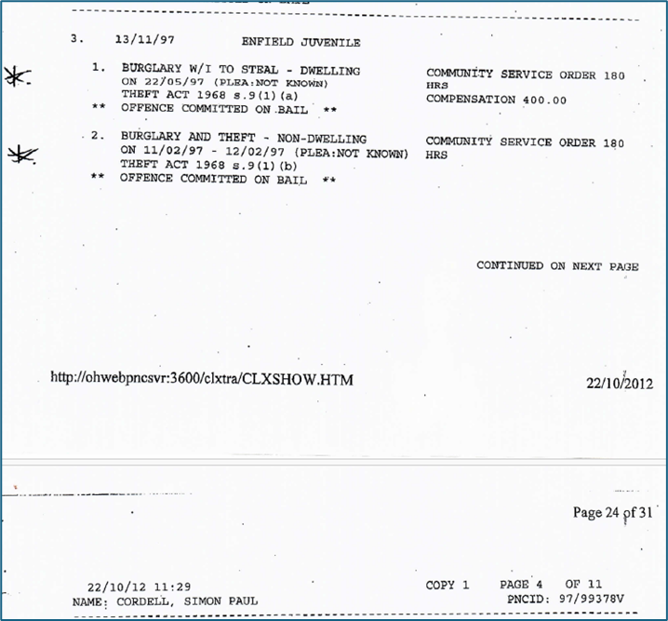
- Screenshot-Before Pre-Reprimand and/or Police Caution Offences: Exhibit 14, Conviction 3 “Text Version of Snippet above from PNC File.”
★
3. | 13/11/97 Enfield Juvenile
1. | Burglary W/I To Steal - Dwelling On 22/05/97 (Plea: Not Known) Theft Act 1968 S.9(L)(A) | Community Service Order 180 Hrs  Compensation 400.00
** | Offence Committed On .Bail **
2. | Burglary And Theft - Non-Dwelling On 11/02/97 - 12/02/97 (Plea: Not Known) Theft Act 1968 3.9(1)(B) | Community Service Order 180 Hrs
** | Offence Committed on Bail *'*

** ------Next------- **

- 11/02/97 + 12/02/97 (Court Plea Dates 3): “Court Adjudication Date: This is the date to Compare against.”
- Details:
- 1X Burglary and Theft – non-dwelling.
- Court Sentencing: 13/11/97 (3rd sentencing date).
- Contradictions:
- 13/11/97 missing from the court registry (Case Ref: 97/0000/00/768545U). this is as proved by my mother emails and the government officials who were also involved as detailed below in the next section of this “Pre-Action Conduct Letter!”

- The (Case Ref: 97/0000/00/768545U,) starts to cause an and is now addressed under the next Screenshot exhibited.

- This offence “Precedes” the first reprimand/warning date 21/08/97, further supporting the fraudulent nature of this record.

    - Additional Notes:
- This is Arrest 60. Disposable 73. In the Acro Report 2017.
- This is also Conviction 3 in the 2012 PNC Printout.

- Screenshot-Before Pre-Reprimand and/or Police Caution Offences: Exhibit 12, Conviction 3 “Snippet from PNC File.”
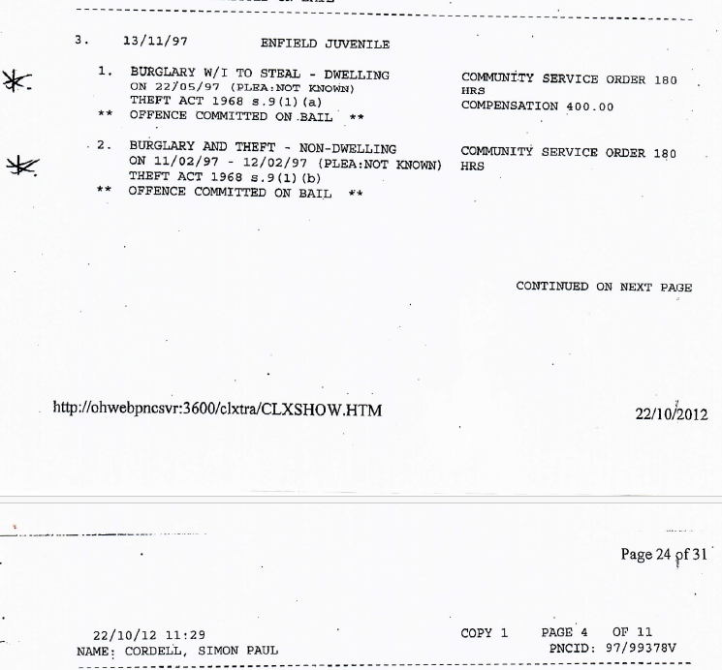

- Key Findings:
- The repetitive discrepancies across offences demonstrate “Systemic Fraud” within the Acro record. Entries that precede the “First Reprimand/Warning Date” contradict lawful procedural timelines, proving these records are fabricated or manipulated.
- The Case Ref: 97/0000/00/768545U is central to this issue, showing one arrest recorded in the Acro Report but linked to “Two Different Disposable Numbers,” “73” and “74”, totalling “Three Separate Cases.” This creates confusion due to the following findings:
- Disposable 73:
- Court Sentencing Date: 12/11/1997.
- Includes “Three Driving-Related Offences” dated 22/05/1997 (08:45 to 16:20) with all occurring on the same day.
- Disposable 74:
- Court Sentencing Date: 13/11/1997.
- Features “Two Distinct Burglary and Theft Cases:
- Non-Dwelling Burglary: Offence dated 11/02/1997–12/02/1997.
- Dwelling Burglary: Offence dated 22/05/1997.

- Both offences are “Approximately 2.5 Months Apart” yet oddly sentenced together as guilty on the same day (13/11/1997) at the Enfield Juvenile Court.

- Critical Observations:
- All three offences share a Plea: “Not Known” status.
- Court documentation describes bail conditions from 08/10/1997, listing appearances at Enfield Magistrates on 22/10/1997, followed by sentencing dates (12/11/1997 and 13/11/1997).

- Documented Irregularities:
- Disposable 73's “Three Offences” are linked to “Conviction (2) in the PNC 2012 Printout,” including:
- Burglary W/I to Steal – Dwelling.
- Driving-Related Offences: Dated 22/05/1997 with unknown plea statuses.
- Disposable 74's “Two Offences” are linked to “Conviction (3) in the PNC 2012 Printout,” which highlights:
- Non-Dwelling Burglary: Dates contradict procedural norms.
- Dwelling Burglary: Offence dated 22/05/1997.
- The plea date inconsistencies illustrate procedural impossibilities:
- Simultaneous plea entries contradict logical court processing timelines due to overlapping offence and court appearance dates.

- Arrest 60's Misrepresentation:
- All three cases share the same “Arrest/Summons Ref: 97/0000/00/768545U,” indicating a singular arrest linked to all offences. However:
- Documentation states “I Was Not Charged on the Arrest Dates,” invalidating the claims.
- The Acro Report misleadingly consolidates the cases under one arrest, contradicting the “PNC Printout,” which implies charges and court dates match offence dates, a procedural impossibility.

- Systemic Fraud Indicators:
- The Acro Report and PNC Printout contain irreconcilable contradictions, such as:
- Claiming simultaneous arrests, charges, and court pleas on the same dates as the offences.
- Fabricated timelines aligning offences under “Arrest 60,” obscuring the truth.
- Procedural violations, like charging and plea entries outside lawful court hours.
- In Layman Terms:
- Within the Acro Report, it is stated that all three of these cases are linked to “Arrest 60”, sharing the same “Arrest/Summons Ref: (97/0000/00/768545U).” This implies one singular arrest for all offences.
- However, this cannot be accurate due to procedural violations and systemic fraud, as outlined within this claim and here:
- I could not have been arrested on these dates, charged, and brought to court on the same day to enter a plea, as the documents indicate. ‘The ACRO Report’ shows that I had not yet been charged at the time of those arrests.
- It seems that a warrant may have been issued, resulting in multiple arrests being consolidated into one incident referred to as ‘Arrest 60’ in the ‘ACRO Report 2017,’ this is evidenced by the same summons number for all the arrests. However, this contradicts the ‘PNC Printout’s,’ which all state that I was charged and went to court on the same days as the offense dates.

- Arrest 60 Acro Report 2012
- Arrest / 2017 Acro = 97/0000/00/768545U = Remand x1 X2 Disposables!

Arrest/Summons Ref: 97/0000/00/768545U
Name Charged: CORDELL, SIMON PAUL
Date of Birth: 26/01/81
Fingerprint Status: CONFIRMED 66 (NIS - NATIONAL IDENTIFICATION SERVICE)
09/09/97
Process Stage: CHARGED ON 01/09/97 21:18
Arresting Officer: URAND/PC/194672
Report Owner: 01 (METROPOLITAN POLICE)
Prosecuting Agent: CPS (CROWN PROSECUTION SERVICE) Last Updated: 09/09/97

Remand

Description: REMANDED ON BAIL ON 08/10/97
At: AT ENFIELD MAGISTRATES
To Appear At: NEXT APPEARING ON 22/10/97
At: AT ENFIELD MAGISTRATES
Owner: 01 (METROPOLITAN POLICE)
Last Updated: 09/10/97
Bail Address: BAIL ADDRESS: 23 BYRON TERRACE ED MONTON LONDON N9
Condition 1: TO RESIDE AT BAIL ADDRESS
Condition 2: TO OBSER VE A CURFEW BETWEEN 9PM & 7 AM
Condition 3: NOT TO CONTACT DIRECTLY/INDIRECTLY PROSECUTION WIT NESSES OR INTEREFER WITH IN ANY MANNER

Three of Three

- Missing From The Court Registry! Mother Proved

- The Reason the Now Claimant Requested the ACRO Report
- The Now Claimant first became aware of inaccuracies in his criminal record during legal proceedings, where errors within the police printout of his criminal record became evident.
- At a crucial stage of the proceedings, a failure-to-surrender charge was shown on the Claimant's criminal record. The Claimant argued that this charge was inaccurate and unfounded at the time, but despite raising objections, the custody officer refused bail, deferring the matter to the court for resolution.
- Upon appearing in court, the presiding judge refused to hear verbal submissions from the Claimant or his legal team regarding the criminal record's inaccuracies. This led to the Claimant being remanded in custody based on the erroneous charge.
- Subsequently, the Claimant’s legal team obtained a copy of the police’s criminal record, which they presented in court alongside evidence proving its inaccuracies. Following this application, the judge granted bail under strict conditions.
- These events prompted the Claimant, his legal team, and his family to initiate inquiries to rectify the errors in the criminal record to ensure such issues would not reoccur.

- Efforts to Address Inaccuracies in the Police Criminal Record
- In 2013, the Claimant and his mother began systematically reviewing the criminal record and cross-checking it with court registries. They contacted relevant courthouses to question arrest summons numbers and discrepancies in the police printout.
- Among the errors they identified were:
    - Offence and court dates not aligning with official records.
    - Several instances of court dates entirely missing from the court registry.
    - Charges being listed inaccurately, without any supporting evidence, or being dismissed in earlier proceedings.

- Specific Instances Of Errors Include:
- 21/05/98: Not found in court records.
- 05/01/01: Not found in court records.
- 17/08/02: Not found in court records.
- 24/04/03: Not found in court records.
- 25/01/08: A failure-to-surrender charge dismissed by the judge.

- As Exhibited Here:

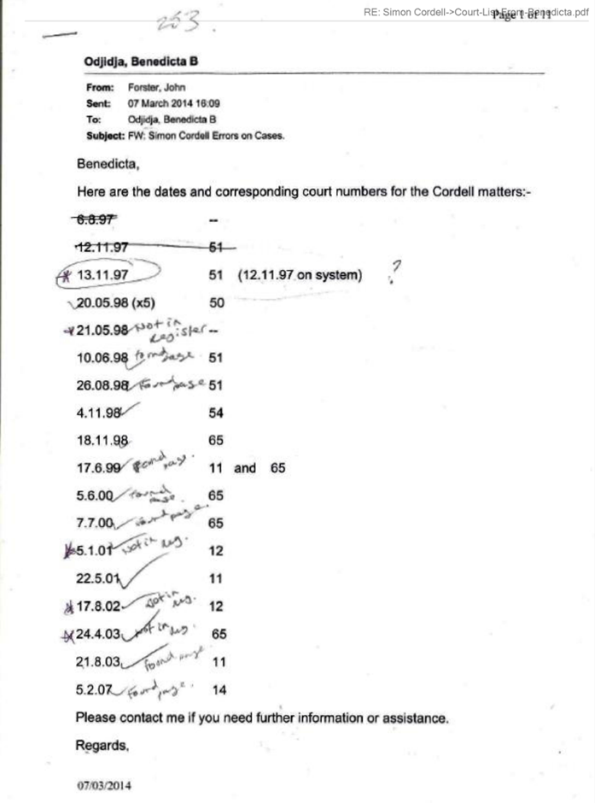

- The Claimant and his mother repeatedly raised concerns via emails and personal visits to courthouses, requesting clarification and evidence to address these discrepancies.

- As Exhibited Here:
- 1-PNC-Original-Emails
- 3-PNC-Emails-Additional-Files-02-12-23

Sent: 18 September 2015 15:00

Attachments: Court-List-From-Benedicta.pdf

- Evidence of Collusion and Fraud
- Their investigation uncovered patterns indicating systemic issues in how the Claimant’s criminal record was maintained:
- Errors in court dates and charges suggest that records were inaccurately updated, or key data was fabricated to reflect unfounded offences.
- The refusal of authorities, including police and courts, to correct these errors despite the evidence presented adds to concerns of negligence or deliberate misconduct.

- Ultimately, the investigation revealed fraudulent practices within the Claimant's criminal record. The errors in the records and the systemic failure to address them have obstructed justice and caused undue harm to the Claimant.

- Impact of Fabrications
- Fabricated intelligence and refusal to delete fraudulent records directly obstructed the claimant’s ability to act earlier. Furthermore:
- The systemic collusion among public entities deliberately prolonged the resolution process, adding extraordinary circumstances to justify the extension of time limits under Section 32.
- The resulting harm to me both procedural and reputational, underscores the severity of these actions and the necessity for accountability.

- Fraud Conclusion
- The systemic misconduct, collusion, and fraudulent records maintained by the police, council, courts, and Acro department constitute deliberate concealment under Section 32 of the Limitation Act. These actions obstructed the claimant from taking earlier legal action and justify the suspension of the limitation period. The fabricated records, proven through careful analysis of the PNC and Acro documents, further emphasize the urgent need for judicial intervention to address these injustices.

- The findings from the Claimant's inquiries into the police’s criminal record and related Acro records highlight a broader issue of systemic inaccuracy and negligence. These inaccuracies, some of which appear to be intentional fabrications, justify further scrutiny, and support the argument of fraud in maintaining the Claimant’s records.

- Legal Framework and Human Rights Violations
- Fraud Act 2006:
- Section 2: Fraud by False Representation of Official Records:
- Misrepresentation of Arrest Dates: Inaccurate arrest dates disrupt legal proceedings and infringe upon individuals' rights.
- Plea Timelines: Manipulated timelines mislead judicial processes, undermining fairness and integrity.
- Procedural Accuracy: Falsified procedural details erode the reliability of official documents. Collectively, these violations justify liability and necessitate accountability.
- Section 3: Fraud by Failing to Disclose Information:
- Failure to address or rectify contradictory timelines and irregularities constitutes deliberate obstruction and deepens systemic misconduct.
- Limitation Act 1980 (Section 32):
- Fraudulent concealment suspends standard time limits, ensuring that claims relating to fabrication, collusion, and obstruction can proceed.
- For “Human Rights Cases,” time limits are waived under precedents and international legal standards, emphasising the fundamental principle that justice cannot be limited by procedural barriers when rights are violated.
- Human Rights Act 1998 Violations
- Article 2: Right to Life
- The fabrication of records has caused irreparable harm to my livelihood, career prospects, and personal development. These actions perpetuate stigma, harassment, and alienation, infringing on my right to live a dignified and fulfilling life.
- Article 6: Right to a Fair Trial:
- Manipulated records have deprived me of procedural justice, preventing a fair opportunity to defend against fabricated charges.
- Article 8: Right to Private and Family Life:
- The falsified records damaged my reputation and personal relationships, breaching my right to privacy and family life.
- Article 14: Prohibition of Discrimination:
- Fabricated records were systematically weaponised to target and discredit me based on identity crises and stereotypes, perpetuating institutional bias.
- This discrimination encouraged cruel behaviors, alienating me socially and professionally.
- Time limits cannot constrain these claims, as they involve “Human Rights Breaches” with profound and ongoing impacts. Such violations demand “Justice” regardless of when the harm was first discovered.

- Systemic Fraud Indicators
- The “Acro Report” and “PNC Printout” contain clear systemic fraud indicators, including:
- Simultaneous procedural events (Arrests, Charges, And Pleas) falsely attributed to the same dates.
- Fabricated timelines consolidating multiple offences under “Arrest 60” to obscure procedural truth.
- Procedural violations, such as charges and pleas, recorded outside lawful court hours.

- Impact on Dignity and Livelihood
- The Fraudulent Records:
- Denied me equal opportunities for employment, exacerbating “Psychological And Social Burdens.”
- Subjected me to “Stereotypical Harassment,” further revealing systemic flaws that disregard “Human Rights.”
- These breaches unequivocally establish liability for violating “Legal Standards” and “Fundamental Rights.” “Waiving Time Limits For Human Rights Cases” is essential to ensure justice and accountability for systemic misconduct.

- Systemic Fraud Indicators:
- The Acro Report and PNC Printout Contain Irreconcilable Contradictions, Such As:
- Claiming simultaneous arrests, charges, and court pleas on the same dates as the offences.
- Fabricated timelines aligning offences under “Arrest 60,” obscuring the truth.
- Procedural violations, like charging and plea entries outside lawful court hours.

- Extraordinary Circumstances:
- Evidence of collusion across multiple entities (Police, Council, Courts, And Doctors) demonstrates coordinated efforts to discredit me, and this included having "Joint Circular" meetings about me, where their plans to obstruct and harass me were executed. This systemic obstruction constitutes to extraordinary circumstances beyond my control.
- Overloading me with documentation, while delaying Subject Access Requests that we put them in receipt off. The liable denied access to critical information when they used deliberate tactics to prolong delays in my claim.

- Continuous Damage and Ongoing Harm:
- Persistent harassment fabricated legal actions (Such As The Fraudulent ASBO Alleging Illegal Rave Organization), and refusal to address violent attacks against me caused ongoing harm. The lasting physical and emotional distress, compounded by their refusal to delete fabricated data, supports the argument for “Continuous Damage,” which extends the time limits for filing.

- Protected Party Allegations:
- The defendants falsely claimed I was of unsound mind, despite no medical diagnosis supporting these allegations. This baseless accusation was used to discredit my claims and delay proceedings unfairly.

- Human Rights Violations:
- The actions taken by the defendants constitute breaches of the “Human Rights Act 1998,” including:
- Article 6: Denial of my right to a fair trial through systemic obstruction and fabrication of evidence.
- Article 3: Subjecting me to degrading treatment by enabling harassment, false accusations, and fabricated intelligence.

- Time Limits and Discovery:
- The coordinated efforts of the police, council, courts, and doctors were uncovered through separate Subject Access Requests and cross-referenced release notes. Only by putting these together was I able to uncover the systemic collusion and obstruction that had prevented me from asserting my rights earlier.

- Judicial Discretion and Accountability:
- Courts have discretion to extend time limits when equitable and reasonable under the circumstances. The systemic nature of the misconduct, the substantial evidence presented, and the significant public interest in holding these entities accountable necessitate judicial intervention.

- Evidence of Prior Successes:
- My successful outcomes in previous legal battles, such as two possession orders and two injunctions, demonstrate the merit of my case and the lengths to which the defendants have gone to discredit me.

- Impact on Daily Life:
- The systemic abuse caused me to fear leaving my own front door due to persistent setups and harassment. This demonstrates the profound impact on my daily life and strengthens the argument for extended time limits.

- Public Interest and Systemic Accountability:
- Exposing the coordinated efforts of public entities to harass, obstruct, and discredit an individual is in the broader public interest. Systemic misconduct by those entrusted with public service cannot go unaddressed.

- Conclusion
- The combined evidence of fraud, concealment, extraordinary circumstances, continuous damage, and systemic misconduct unequivocally justifies extending the limitation period under “Section 32 of the Limitation Act 1980.” This case highlights not only the need for accountability but the urgent requirement for systemic reform to prevent such injustices from recurring.

- Provided Below Is the Accused Company Details in Year Order of Accused as Liable.
- Please take a note that Due to the size of the file, we have attached the accused as labels names in a separately attached sheet.
- For the following claims that Our Client has against you, which we have detailed in this official document and its affiliated documents, according to the years relevant to each Recipient: –

- Explanation:
- The table below summarizes the accused parties in chronological order, providing their details and categorizing their potential liabilities.

- This Includes:
- Direct liability for fraudulent input or updates to the PNC and ACRO reports.
- Liability for creating or enabling fabricated cases used through the police, courts, and related entities in civil and criminal matters.

Year | Entity | Address | Contact Information | Fraud in PNC / ACRO The Top Three Examples | Fabrication of Cases
1997 | Youth “Justice” Team | Claverings Industrial Estate, 3 South Way, Edmonton, London, N9 0AB | Tel: 020 8379 5800 | Not Applicable As Not Directly Involved In Updating Acro Reports! | Swan Youth Justice.  Failed To Prevent Fabrication
1997 | Youth “Social” Services | 1 Orton Grove, Enfield, EN1 4TU | Tel: 020 8379 5802 | Not Applicable As Not Directly Involved In Updating Acro Reports! | Facilitated Or Failed To Prevent Fabrication  Indirect Oversight
1997 | Metropolitan Police Force & Other Associated Forces | Claverings Industrial Estate, 3 South Way, Edmonton, London, N9 0AB | Tel: 020 8379 5800 | Complicit In Updating Of Acro Report Fraudulent Entries  Complicit In Updating Of PNC Printout Fraudulent Entries | Complicit In Creating Fabricated Cases
1997 | Her Majesty’s Courts, UK | New Scotland Yard, Victoria Embankment, London, SW1A2 | Tel: 999 / 101 | Complicit In Updating Of Acro Report Fraudulent Entries | Failed to ensure accurate legal proceedings
1997 | Crown Prosecution Service (CPS), UK | 102 Petty France, London, SW1H 9EA | Tel: 999 / 101 | Complicit In Updating Of Acro Report Fraudulent Entries  Complicit In Updating Of PNC Printout Fraudulent Entries | Presented And Relied On Fabricated Evidence
1997 | ACRO Department of Criminal Records | PO Box 481, Fareham, Hampshire, PO14 9FS | Tel: +44 (0)23 8047 9920 | Direct involvement in the handling of the Acro Records Fraudulent Entries | Supported fabricated case narratives
2006 | Enfield Homes Repair Teams | 1-3 Gentlemans Row, Enfield, EN2 6PT | Tel: 020 8379 1000 | Not Applicable | Allowed unsafe conditions impacting claims
2012+ | Bow 999 Call Centre | 111 Bow Road, Mile End, London, E3 2AN | Tel: 020 7515 1212 | They necessitated the facilities and resources to commit the Civil Wrongs and crimes | They intentional aggravated the situation and therefore Failed to mitigate fabricated case handlings.  Failed to act on fabricated reports.  Indirect involvement through PNC integration. They acted recklessly in Joint Circular in emergency crisis.
2012+ | Lambeth 999 Call Centre | 109 Lambeth Road, SE1 7 London, United Kingdom | Contact not listed | They necessitated the facilities and resources to commit the Civil Wrongs and crimes | They intentional aggravated the situation and therefore Failed to mitigate fabricated case handlings.  Failed to act on fabricated reports.  Indirect involvement through PNC integration. They acted recklessly in Joint Circular in emergency crisis.
2012+ | Hendon 999 Call Centre | Aerodrome Rd, London NW9 5JE | Tel: +4487078945611 | They necessitated the facilities and resources to commit the Civil Wrongs and crimes | They intentional aggravated the situation and therefore Failed to mitigate fabricated case handlings.  Failed to act on fabricated reports.  Indirect involvement through PNC integration. They acted recklessly in Joint Circular in emergency crisis.
2012+ | Enfield Council | Silver St, London EN1 3XA | Tel: 020 8379 1000 | Indirectly complicit through governance gaps | Enabled and overlooked systematic failures
2012+ | Enfield Neighbourhood Watch Teams | 36-44 South Mall, Edmonton N9 0TN | Tel: 020 8379 10001 | Indirectly complicit through governance gaps | Assisted in community-level fabrications
2012+ | NHS & Private Mental Health Teams | 8th Floor, 10 S Colonnade, Canary Wharf, E14 4PU | Tel: 020 7811 2700 | Indirectly complicit through governance gaps | Medical teams involved in fabricated reports and caused medical negligence to aid in the cases being wrongly avoided.
2012+ | Burncroft Avenue Community | * | * |  | Community-level harassment contributing to fabricated claims
2012+ | DAC Beachcroft | * | * | Not Applicable | Legal firm involved in mismanagement
2012+ | Parliament Members | Westminster, London, SW1A 0AA | Tel: 999 / 101 |  | Lack of intervention

End Of Page!

We Request for Compliance with the Practice of Directions for Pre-Action Conduct: --
- Considering this, we are writing to request that all parties listed as liable comply with the Practice Directions in respect of Pre-Action Conduct before we continue to move forward with court procedures. We request that you comply with the practice directions for pre-action conduct, as set out in the Civil Procedure Rules, by doing the following:
- Providing us with copies of the relevant documents that you hold or control, relating to the above allegations, within 14 days of receiving this letter.
- Considering the possibility of resolving this dispute through alternative dispute resolution, such as mediation, arbitration, or negotiation, within 28 days of receiving this letter.
- Respond to this letter with a full admission or denial of liability, and a detailed explanation of your position, within 28 days of receiving this letter.
- If you fail to comply with the above request, we reserve the right to commence legal action against you without further notice. We also, reserve the right to seek an order for costs and interest from the court if we succeed in our claim.

Nature And Summary of The Claim: --
- Our claim involves the following allegations:
- Racial and discriminatory: profiling committed by the police and other authorities, resulting in harassment, intimidation, and false accusations.
- Conspiracy and fraud: Committed by the council and other parties, involving the misuse of public funds, the falsification of documents, and the violation of our rights and interests.
- Deliberate life endangerment: Committed by the council and other parties, involving the exposure to hazardous materials, the denial of essential services, and the failure to provide adequate protection and support.
- Compensation: We kindly request compensation for the damages and losses our client has suffered due to the misconduct and injustice committed by the police and other authorities. These damages encompass physical, mental, emotional, and financial harm that our client has endured. We firmly believe that it is necessary to rectify this situation by providing appropriate retribution for the harm caused.

Our Summary of Facts: --
- AN ATTEMPT TO SILENCE OUR CLIENT.
  - These incidents have escalated to an extent where it appears there is an attempt to silence Our Client from speaking out about these injustices.

- A CRIMINAL RECORD HAS BEEN FORGED.
  - It has come to our attention that a criminal record has been forged against Our Client, an act that we believe can be proven to be fraudulent. This has not only tarnished Our Client’s reputation but has also caused significant distress and harm to him.

- A COORDINATED EFFORT TO DISCREDIT MY CLIENT.
  - Furthermore, it appears that other government bodies, including Enfield Council, have been implicated in these allegations due to a coordinated effort to discredit my client, which has resulted in fraudulent court applications being brought against him. Despite clear evidence of fraud, these allegations have been dismissed and ignored.

- ILLEGAL ATTEMPTS TO INVOLVE THE NATIONAL HEALTH SERVICE
  - Most alarmingly, it has come to light that our accused as liable have made illegal attempts to involve the National Health Service NHS in this matter, with their apparent intention of using medical intervention to prevent Our Clients from voicing his complaints.

- For A More Comprehensive Understanding of The Claim, We Proceed with The Following Explanations: --

- WRONGFULLY VIOLATED BY GOVERNMENT OFFICIALS
  - Through the years of 1996 till 2024 The claimant, Mr. Simon Paul Cordell, has been Wrongfully Violated by Government Officials claiming to be carrying out their official duties, when the only truth of the matters is that their actions were illegal and have now prevented him from having a safe life in the Country where he was born in as a citizen, and in all honesty it was them the Government Officials who was knowingly abusing their powers of trust for their own wrongful self-gains, as we prove in our supported case files of evidence, such as our N1 Claim Forms.

- POLICE ARRESTS DID NOT WARRANT DETENTION.
  - The claimant's homes in the United Kingdoms & that of the Official Persons buildings have mostly been used as illegal holding cells for him to be held inside off, for much of his life. This was done so, that the police could turn crimes into positive statistics for themselves, to look good in the public’s eye regardless of the truth being that Our Client did not commit those crimes. Mr. Cordell states that the police start wrongly on him at first sight, and this has happened to him throughout 97.6% of the police's intervals that he is forced to be put through and this is in part why Our Client is stating that the police have continued to manipulate the truth from their own made-up assumptions against him, to gain their own statistics, in them knowing that their Police Arrests did not warrant detention, as the criminal record attached to his name proves.

- THE EXHIBITED PNC WORKOUT-FILES.
  - The Metropolitan Police Officers' abusive cycle against Our Client is an easy-to-spot piece out of our evidenced exhibits, as for when any person is the beholder of Our Official Documentation and he or she takes the time to read over them, as to what they will conclude, from the Exhibited PNC Workout-Files that we have provided for all to read, is that it becomes apparent that the police have forcefully repeated their illegal patterns time and time again and abusively against Our Client. This wrong, yet repetitive cycle, created by the police, demonstrates abuse of police powers against him since he was an adolescent.

- OFFICIAL PERSONS TURNING A BLIND EYE
  - His current home, rented to him by the Enfield Council & Co, since 2006 is a place of a crime scene due to official persons turning a blind eye, conducted after 2013 so, they can avoid justice. It is not a safe home for him or others to reside in, after those who rented it to him and those who are there to protect it and him and his loved ones, all decided to set him up so, that he can wrongly be victimised. This was done to Our Client by members of Government Officials & inclusively of members of his neighbours and it is said that they all are endangering his life deliberately while they were illegally detaining him for years at a time without any crime being proved as committed by him since he was a child.

- THE CLAIMANT COMPLAINED OF HIS LEGAL RIGHTS BEING VIOLATED
  - When overviewing the evidence for the cases we have supplied, it is more than fair to say that it becomes apparent that the claimant complained of his legal rights being violated at every stage of his aggressors' aggression, as did others on his behalf.
  - He was screaming for sympathy as an innocent person, but all his and his other persons' complaints that they all brought through the correct government channels stayed to no avail.
  - It is said that the Government Officials and Our Client's neighbours alike were torturing Mr. Cordell, though the years of 2013 till 2024 in knowing what they were doing to him was vastly illegal.
  - They all intentionally chose to stay as his aggressors, who are named as members of the United Kingdom's Government Officials and also, members of his neighbours to who None showed any empathy towards Our Client as they involved sadly chose to continue in their evil cruel ways that is said to be a wrong perception for a modern reality in a humane world, as they refused to follow the land's rules of right and continued to torture him, until date of this Pre Action Conduct Letter being submitted.

- REFUSING TO ACKNOWLEDGE VARIOUS TYPES OF EVIDENCE REQUIRED FOR ANY FAIR INVESTIGATIONS
  - The staff of Enfield Council, along with members of the Metropolitan Police Force, NHS Mental Health Teams, and Private Mental Health Teams, are all accused of refusing to acknowledge various types of evidence required for any fair investigations and legal proceedings to take place for our client, and, for fabricating evidence maliciously against him. It is alleged that Our Client and others requested a thorough investigation into their claims against those listed as liable, but they, along with other government officials, failed Mr. Simon Paul Cordell, and his family.
  - Their failures attributed to not following strict company protocols and government regulations, resulting in a lack of evidence collected and other materials that were fabricated that if not could have led to the right arrests and convictions, as mandated by UK law for a successful modern society. The types of evidence that should have been collected & not fabricated against him include, but are not limited to, the following materials: –
- Analogical Evidence: which uses comparisons to clarify or explain situations.
- Physical Evidence: Tangible items like stolen goods found in an employee’s locker, or under their computer identifications, as to electronical data.
- Illustrative Evidence: Visual aids such as charts, graphs, photos, models, or recordings.
- Direct Evidence: That Directly proves a fact, like eyewitness accounts, which are not forged against him and/or his claims.
- Circumstantial Evidence: Indirect evidence that implies a fact but does not directly prove it, that is not forged against him and/or his claims.
- Primary Evidence: Original documents or objects, that are not forged against him and/or his claims.
- Secondary Evidence: Copies or substitutes of original documents, which have not been forged against him and/or his claims.
- Forensic Evidence: Scientific evidence like DNA or fingerprints.
- Expert Evidence: Testimony from individuals with specialized knowledge, which did not aid in crime by fabricating testimonial statements against Our Client in knowing that what they & others were all doing to him was taking apart in crime instead of their legal duties being conducted in accordance with their legal statues.
- A fair investigation into Our Clients claims would have meant that Government Officials would have intervened and acted accordingly to United Kingdom Laws and company policies, as our collected evidence for each case we attach proves has not happened.
  - The correct investigations would have led Our Client to the correct arrests and could have easily prevented the death of his three unborn children, that he continued to contact them about after the loss of the first child as to when he asked the Government Officials for legal help as a victim of crime. The claimant asserts that all three children would be born alive if the Officials had listened to him and others and acted in a fair and speedy manner when requested. Despite his upset, he states he can still provide evidence supporting his claims, which the official persons continue to ignore to this date!
  - The cause of the death of the three unborn children is said to be partly due to his rented home, which was and still is technically being used as a trap house where he can be tortured by official persons who have abused their powers of trust to prevent the Now Claimant from making an insurance claim against themselves and that this is all while they fuelled his Neighbours full of fake truths so, that they as the Now Claimants Neighbours, viciously bang on the walls and ceilings of his flat, Morning In & Day Through, while Night Out, to get rid of him in anyway what soever, as to what the Government Officials had betrayed about him and then afterwards needed to coverup.

- CLAIMANT RECEIVED DAMAGES TO HIS ENTERTAINMENT COMPANY, “TOOSMOOTH.”
  - The claimant received damages to his entertainment company, “TooSmooth,” due to our accused as liable, which he and others were building. The company was a hire company, and Our Client had highly invested money and time into building his company. He and others were in the process of turning his company into a festival that represented London and its inner and outer talent. However, due to the wrongful interventions of Government Officials, such as a continuous stream of forged official court order applications that we submitted, the company was forced to sit to the side while forged court battles continued.

- FORGED OFFICIAL COURT ORDER APPLICATIONS, DEVELOPED BY GOVERNMENT OFFICIALS.
  - The continuous flowing stream of forged official court order applications, developed by Government Officials and brought before the courts from 2014 till 2020, were set out to deprive the claimant from being able to prove his innocence in court, unfairly. But he and others were determined not to let right lose, especially when he was being set up. Eventually, as the years faded away, all their determination was not lost as they won all the forged official court order applications, except for minus one case that he should never have lost in the courts. The Government Officials have since refused to fairly review any of the official court order applications or cases, that they brought against Our Client, in our belief, so, that they can avoid the Now Claimants Claims, meaning that Our Client's claims have stayed as none investigated. This means that not one of the identified criminals that can easily be identified for their crimes has been apprehended by the Government Officials as they, as the representing Officials of the United Kingdom's Land, have all simply refused to make even one arrest for what can be proved to be true by Our Client or anyone else as, of so far, even though he holds an impenetrable defence.

This Is About Our Provided List of Documents of Evidence: --

The Files We Mention & Include: --
- Court case files and transcripts of the proceedings that we have initiated or participated in, relating to the above allegations.

- Recorded telephone calls and emails and their associated mailing lists that we have made or received, relating to the above allegations.

- Medical reports and certificates that we have obtained, relating to the physical and mental injuries that we have sustained.

- Financial statements and receipts that we have issued or received, relating to the expenses and losses that we have incurred.

- Photographs and videos that we have taken or obtained, relating to the conditions and situations that we have faced.

- Witness statements and affidavits that we have collected or received, relating to the testimonies and experiences of other people who have witnessed or suffered from the above misconduct and injustice.

Listed Below Are the Case names & there associated dates, on Which We Intend to base our Claims Against You and in those following submitted files are the dates, locations, names, and actions of the alleged incidents, which demonstrate how Our Clients harms & losses were caused and for each case mentioned above, we have meticulously organized individual folders. Within these folders, we have included all relevant documents that serve as evidence for each respective case. Our intention is to rely on these documents and pieces of evidence, which we believe strongly support our claim.

Title: A-Shadow-Copy-of-The-External-File-Structure-Chart
- Due to its size, we have attached the Shadow Copy of The External File Structure Chart as a separate sheet. This document provides a meticulously created and highly detailed representation of the external file structure. We have taken great care to accurately present the arrangement of the files, ensuring maximum clarity and precision.

Title: Summery-Explanation-of-Submitted-Internal-Files-Chart
- In a separate attachment, we have provided the Summary Explanation of Submitted Internal Files Chart, also due to its size. This document offers a comprehensive overview of the reasons behind the submission of our internal files. It goes beyond the necessity of proper documentation and organization, aiming to enhance efficiency, accessibility, and the overall quality of our work. The chart outlines the specific reasons for submitting both external and internal files and highlights their significant importance to our operations.

About The Evidence We Have Presented: --
- From "forged acro reports," otherwise known as a PNC Record or Criminal Record, being forged in a different way every time it is requested from Government Systems, to a "Forged ASBO Application," and more, here are a couple of the PNC court cases: --
Please look in the attached document:

EXHIBITS FOR THE N1 CLAIM FORM

No More DNA
Files:
1-Combined-2017-2020-2021-WorkOut-Code-4-PNC-27-08-23
1-Combined-2017-2020-2021-WorkOut-Code-4-PNC-27-08-23.docx

5-Our-Request-Sheet-Police-Acro-Markers.
01-Our-Request-Sheet-Police-Acro-Markers.docx
6-Our-Request-Sheet-Arrests-Acro-Interruptions-Made-By-Police.
02-Our-Request-Sheet-Arrests-Acro-Interruptions-Made-By-Police.docx

Search for: DNA Report in The Our-Request-Sheet it’s a bit messy but I put the info below also search “DNA” in the combined file for the original detail in the Acro Report.
Outcome the police have no legal reason to hold my DNA due to having no DNA simples attached to any wining cases.

DNA Report Summary / 2021 Acro =
WORK OUT CODE | 26
DNA Report 1
Arrest/Summons Ref.: | 06/0000/00/397207P
DNA Status: | CONFIRMED
Sample Barcode: | 96988294
Date of Sample: | 15/05/06
Sent to Lab: | FORENSIC SCIENCE SERVICE (FSS)
Sample Type: | SWAB
DNA FS Ref.: | 42 (ESSEX POLICE)
Fingerprint Status: | CONFIRMED
Test Method: | SGMPLUS (SECOND GENERATION MULTIPLEX PLUS)

The Now Claimant won this case at court and requests the files removal.
DNA Report 2
WORK OUT CODE | 55
Arrest/Summons Ref.: | 97/0000/00/193878F
DNA Status: | CONFIRMED
Sample Barcode: | 90437213
Date of Sample: | 28/02/97
Sent to Lab: | FORENSIC SCIENCE SERVICE (FSS)
Sample Type: | SWAB
DNA FS Ref.: | 01 (METROPOLITAN POLICE)
Fingerprint Status: | CONFIRMED
Test Method: | SGM (SECOND GENERATION MULTIPLEX)

For DNA Report 2
- This DNA Report says it for the following case: -
- Taking Motor Vehicle Without Consent
- Using Vehicle While Uninsured
- Driving Otherwise Than in Accordance with A Licence
- For this case as well as others the Plea dates are not correct as they are the same as the offence dates in the Acro Reports and the PNC Printouts.
- But “DNA Report 2” also states it for a case in 1997 before the first reprimand warning!
- 21/05/98 not in the Court reg and it wrote it’s not there. 97/0000/00/193878F by the Courts Staff admitted in the Emails between them.

DNA Report 3
WORK OUT CODE | 18
Arrest/Summons Ref.: | 07/01YT/01/34813D
DNA Status: | DESTROYED
Sample Barcode: | 98407055
Date of Sample: | 23/11/07
Sample Type: | SWAB
DNA FS Ref.: | 01 (METROPOLITAN POLICE)
Fingerprint Status: | CONFIRMED

DNA Report 4
WORK OUT CODE | 22
Arrest/Summons Ref.: | 06/0000/00/1629163X
DNA Status: | DESTROYED
Sample Barcode: | 97658916
Date of Sample: | 21/12/06
Sample Type: | SWAB
DNA FS Ref.: | 01 (METROPOLITAN POLICE)
Fingerprint Status: | CONFIRMED
End Taken from ACRO Report 2021.

No More “Further Actions”

No More Disposable Files!

Our Requests: --

These allegations are of a serious nature and warrant immediate attention. We kindly request that a meeting be held to conduct an official investigation into the matter and treat these claims with the seriousness they deserve. If a meeting is not feasible, we ask that you proceed with the following: --
- A Meting to Be Held for An Official Investigation to Take Place: Where Our claims are to be taken in an official format and treated appropriately as of the serious nature of their claims as to what they are for and if the following is not chosen to be adhered towards then for the following to proceed:
- Immediate Rehousing: We request that Mr. Simon Paul Cordell be promptly rehoused in accordance with the court order issued by the Lower Court of Edmonton North London on 09/08/2018.
- Compensation Settlement: We request that the accused Parties be held liable and agree to our compensation request for the sum of £50,000,000.00 (Fifty Million Pounds UK Sterling). This amount has been calculated based on the number of days the Claimant has suffered due to government company failures, spanning from 1997 to the current year of 2024, totalling 9,900 days. These damages account for: --
- The losses unjustly endured by the Claimant, considering their life expectancy and the hardships they have faced. It is important to note that the Claimant's life expectancy may have been adversely affected by factors such as racial and discriminatory profiling, harassment, conspiracy, fraud, and deliberate life endangerment.

- Legal Fees and Expenses:

- Deletion of Government Records: We also request that all government records pertaining to the Claimant be deleted in accordance with the law, ensuring complete confidentiality and protection of personal information.
- Calculations: Using an approximate value of 365.25 days in a year, we find that 27 years is equal to approximately 9,861.75 days. If we divide 50 million pounds by this number, the outcome is around 5,070.31 pounds per day. Now, if we divide this amount by 13, Government Companies the result would be approximately £389.26 Per Day. Therefore, if 50 million pounds were divided evenly over 27 years and then further divided by 13, each portion would amount to approximately £389.26 Per Day.
- Additional Notes of importance are: The claimant's mother, who has also been adversely affected by the negligence of the 13 government companies, magnanimously states that if her son receives the full requested sum of money, she will graciously refrain from pursuing her own claim for compensation. This selfless act demonstrates her unwavering belief in the fairness and just resolution of the matter. By putting aside her personal grievances for the greater good, she exemplifies an admirable character that not only seeks rightful restitution but also seeks to contribute to the overall well-being of all parties involved. Her decision showcases a remarkable sense of empathy and understanding, elevating this case to one of exceptional and commendable circumstances.
- We trust that you will give due consideration to our requests and take appropriate action in this matter.

In Accordance with The Practice Direction on Pre-Action Conduct, We Request That You Provide Us with Copies of The Following Documents: --
- Material we have, but have not reviewed: --
- There is no material in our possession that we have not reviewed.

- Material We Request to Obtain: --
- There is still outstanding material that we believe our accused as liable should put us in receipt of and that is as follows: --
- We request for all files that have been developed after the dates of the last subject access requests made by Mr. Simon Paul Cordell and others acting on his behalf, when prior accessing data held about himself & these dates account for: --
- The Metropolitan Police, 28/07/2021 Till Date of This Letter of Pre Action.
- The Enfield Council, 24/01/2017 Till Date of This Letter of Pre Action.
- The NHS North London, 16/02/2019 Till Date of This Letter of Pre Action.
- We can confirm that Our Client would be agreeable to mediation and would consider any other system of Alternative Dispute Resolution [ADR] to avoid the need for this matter to be resolved by the courts. We would also, invite you to put forward any proposals in this regard.

P.S: --
- During Our Investigation, We Have Identified Potential Breaches of The Following Laws, Which We Believe Are Pertinent to This Case and They Are as Follows: --
- *BREACHS VIOLENT DISORDER PUBLIC ORDER ACT 1986 “AS SEEN ON TV!” S.2 _+
- S.18 Use of words or behaviour or display of written material.
- S.19 Publishing or distributing written material.
- S.20 Public performance of play.
- S.21 Distributing, showing, or playing a recording.
- S.22 Broadcasting or including programme in cable programme service.
- Perverting The Course of Public Justice (Common Law): The maximum sentence is life imprisonment.

- Fabrication Of Evidence with Intent to Mislead a Tribunal (Common Law): The maximum sentence for this offense can vary but is typically a significant term of imprisonment.

- Perjuries (7 Offenses) (Perjury Act 1911 Ss.1-7(2)): The maximum sentence for each perjury offense is up to seven years in prison.

- Corruption In Public Office (Public Bodies Corrupt Practices Act 1889 S.1): The maximum sentence is life imprisonment.

- Concealing An Arrestable Offense (Criminal Law Act 1967 S.5): The maximum sentence is imprisonment for up to six months or a fine, or both.

- Assisting Offenders (Criminal Law Act 1967 S.4(1)): The maximum sentence is imprisonment for up to two years.

- False Statement Tendered Under Section 9 Of the Criminal Justice Act 1967 (Criminal Justice Act 1967 S.89): The maximum sentence can vary depending on the specific offense and circumstances.

- Making A False Statement to Obtain an Interim Possession Order (Criminal Justice and Public Order Act 1994 S.75(1)): The maximum sentence can vary depending on the specific offense and circumstances.

- False Statement Tendered Under Section 5B Of the Magistrates' Courts Act 1980 (Magistrates' Courts Act 1980 S.106): The maximum sentence can vary depending on the specific offense and circumstances.

- Fraud by False Representation (Section 2), Fraud Act 2006 / Fraud Company Act 2006: The maximum sentence for this offense is up to 10 years' imprisonment.

- Fraud by Failing to Disclose Information (Section 3, Fraud Act 2006 / Fraud Company Act 2006: The maximum sentence for this offense is up to 10 years' imprisonment.

- Fraud by Abuse of Position (Section 4), Fraud Act 2006 / Fraud Company Act 2006: The maximum sentence for this offense is up to 10 years' imprisonment.

- Possession of Articles for Use in Fraud (Section 6), Fraud Act 2006 / Fraud Company Act 2006: The maximum sentence for this offense is up to 5 years' imprisonment.

- Making or Supplying Articles for Use in Fraud (Section 7), Fraud Act 2006 / Fraud Company Act 2006: The maximum sentence for this offense is up to 10 years' imprisonment.

- Participating in fraudulent business executed by a sole trader, i.e. (Section 9), Fraud Act 2006 / Fraud Company Act 2006: The maximum penalty for offenses under Sections 1, 7, and 9 is 12 months' imprisonment on summary conviction and 10 years' imprisonment on conviction on indictment.

- Penalty for offenses under Section 10, Fraud Act 2006 / Fraud Company Act 2006: Section 10 of the Act increases the maximum penalty for offenses contrary to Section 458 of the Companies Act 1985 to 10 years' imprisonment.

- Penalty for Possession of Articles for Use in Fraud (Section 6), Fraud Act 2006 / Fraud Company Act 2006: The maximum penalty for an offense under Section 6 is 12 months' imprisonment on summary conviction and 5 years' imprisonment on conviction on indictment.

Our Conclusion: --
- In closing, we draw your attention to Paragraphs 15 & 16 of the Practice Direction on Pre-Action Conduct and Protocols, which gives the courts the power to impose sanctions on parties if they fail to comply with the direction, including failing to respond to this letter before claim.
- We look forward to hearing from you within 28 days. If we do not receive a response to this pre-action letter within this timeframe, we will have no alternative but to commence legal proceedings without further notice.
- We request a thorough investigation into these matters and seek assurance that any discriminatory practices or injustices will be stopped and addressed promptly and appropriately within 28 days.
- We look forward to your prompt response and action on this matter.
Yours sincerely,
Mr. Simon Paul Cordell & Others.
Signed by:
Dated:

  - It is said that the Defendants: Namely the Enfield COUNCIL intentionally provided false information regarding the availability and extent of their insurance coverage for criminal matters. This deliberate misrepresentation, coupled with a delay in disclosure extended the claim for an additional two years, dated 00/00/0000 can be directly attributed to their own lack of adequate criminal insurance. Such willful concealment has directly obstructed my capacity to commence legal proceedings in a timely manner, causing significant detriment to my case.

